
Performance Testing

Date | 15 March 2026
Team ID | xxxxxx
Project Name | xxxxxx
Maximum Marks | 5 Marks

Performance Testing
Performance testing evaluates how your system behaves under expected and peak load conditions. Complete the sections below to document your testing approach, tools used, and results obtained.

Step 1: Testing Overview

Field | Details
Testing Tool Used | [e.g., JMeter, Locust, k6, Postman]
Type of Testing | [e.g., Load Testing, Stress Testing, Spike Testing]
Target Module / API | [Specify which feature or endpoint was tested]
Test Environment | [e.g., Local / Cloud / Hosted Server]
Test Date

Step 2: Test Scenarios

S.No | Test Scenario /  Description | No. of Virtual  Users | Duration (sec) | Expected Outcome
1
2
3
4


Step 3: Performance Test Results

S.No | Metric | Target Value | Actual Value | Status (Pass /  Fail) | Remarks
1 | Response Time  (Avg) | < 2 seconds
2 | Response Time  (Max) | < 5 seconds
3 | Throughput  (Req/sec)
4 | Error Rate | < 1%
5 | CPU Utilization | < 80%
6 | Memory Utilization | < 80%

Step 4: Observations & Analysis

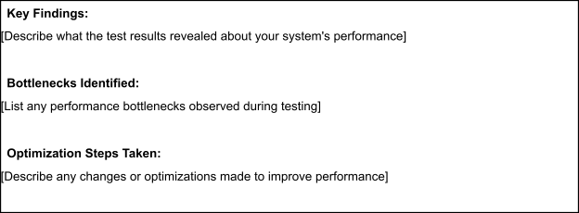

Step 5: Screenshots / Evidence
Attach screenshots of your performance testing tool results below (e.g., JMeter report, Locust graphs, k6 output):



